# Lab 5: Loops – Drawing Shapes More Efficiently

Academic Honesty

* The work you turn in is to be your work, not copied from someone else, from the web, or generated by a program.
* Never allow anyone access to your files.
* Never give anyone your password.
* Never share your USB memory or email your files to anyone else.
* Never give anyone a printed copy of your file or an electronic copy.
* Never allow anyone to copy your work.

Purpose

This lab will let us practice writing if statements, for loops, and graphics

## Functionality

* Ask the user to enter a shape: star, tree, flower, sun, or rubik’s cube
* If the user enters one of the three shapes, then draw that shape
* Make sure your if statement is case insensitive and space insensitive.
* If the user enters text that is not recognized, then present them with an error message.

## Drawing Triangles, and Squares

You will use a **for loop** so that you can draw one side of the square or triangle, and repeat the process to make the whole shape. You will do this for any place you see a square or triangle.

## Drawing a Star

I see two triangles

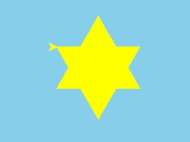

## Drawing the tree

I see 4 triangles or varying sizes, and a square.

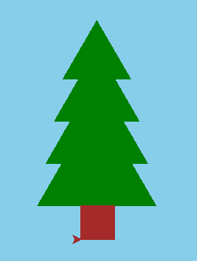

## Drawing a Flower

You will draw a flower by repeatedly drawing circles, and changing the angle. Using a **for loop**.

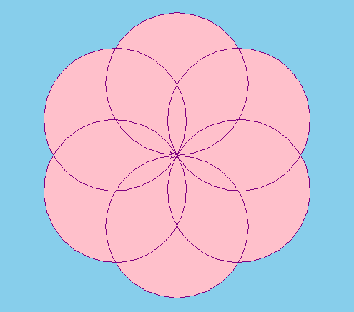

## Drawing a Sun

You will draw a Sun with the same code you used to draw a square, but you will change the angel to 100, and repeat more times, using a **for loop**.

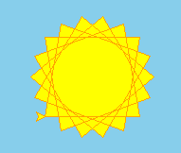

## Drawing a Rubik’s Cube

I see 9 squares

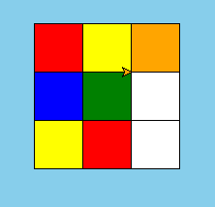

## Sample Program with Invalid User Data



## Submitting your files

* Copy your .py file and move it to your X:\101Labs directory for grading.
* Make sure your file is named Lab5XY.py where XY are your initials
* Print your code, and submit it to your lab instructor at the beginning of your next lab class.

## Grade Breakdown

|  |  |
| --- | --- |
| **Points** | **Expectation** |
| 10% | Comments, listing program, your name, and explaining the code |
| 10% | Correctly gathering user input |
| 20% | If statement to test shapes |
| 60% | Correctly drawing shapes using a for loop |